**Project Design Phase**

**Problem – Solution Fit Template**

|  |  |
| --- | --- |
| Date | 27June 2025 |
| Team ID | LTVIP2025TMID52738 |
| Project Name | Flight-Booking |
| Maximum Marks | 2 Marks |

**Problem – Solution Fit Template:**

The Problem-Solution Fit simply means that you have found a problem with your customer and that the solution you have realized for it actually solves the customer’s problem. It helps entrepreneurs, marketers and corporate innovators identify behavioral patterns and recognize what would work and why

**Purpose:**

• **Convenient Ticket Reservation** – Enables users to search, compare, and book flights easily from anywhere.

• **Real-Time Availability** – Provides up-to-date information on flight schedules, prices, and seat availability.

• **Secure Payments** – Facilitates safe and efficient transactions for booking and cancellations.

• **Customer Data Management** – Stores passenger details to streamline check-in, loyalty programs, and travel history.

• **Automation and Efficiency** – Reduces manual workload through automated confirmations, reminders, and updates.

**Template:**

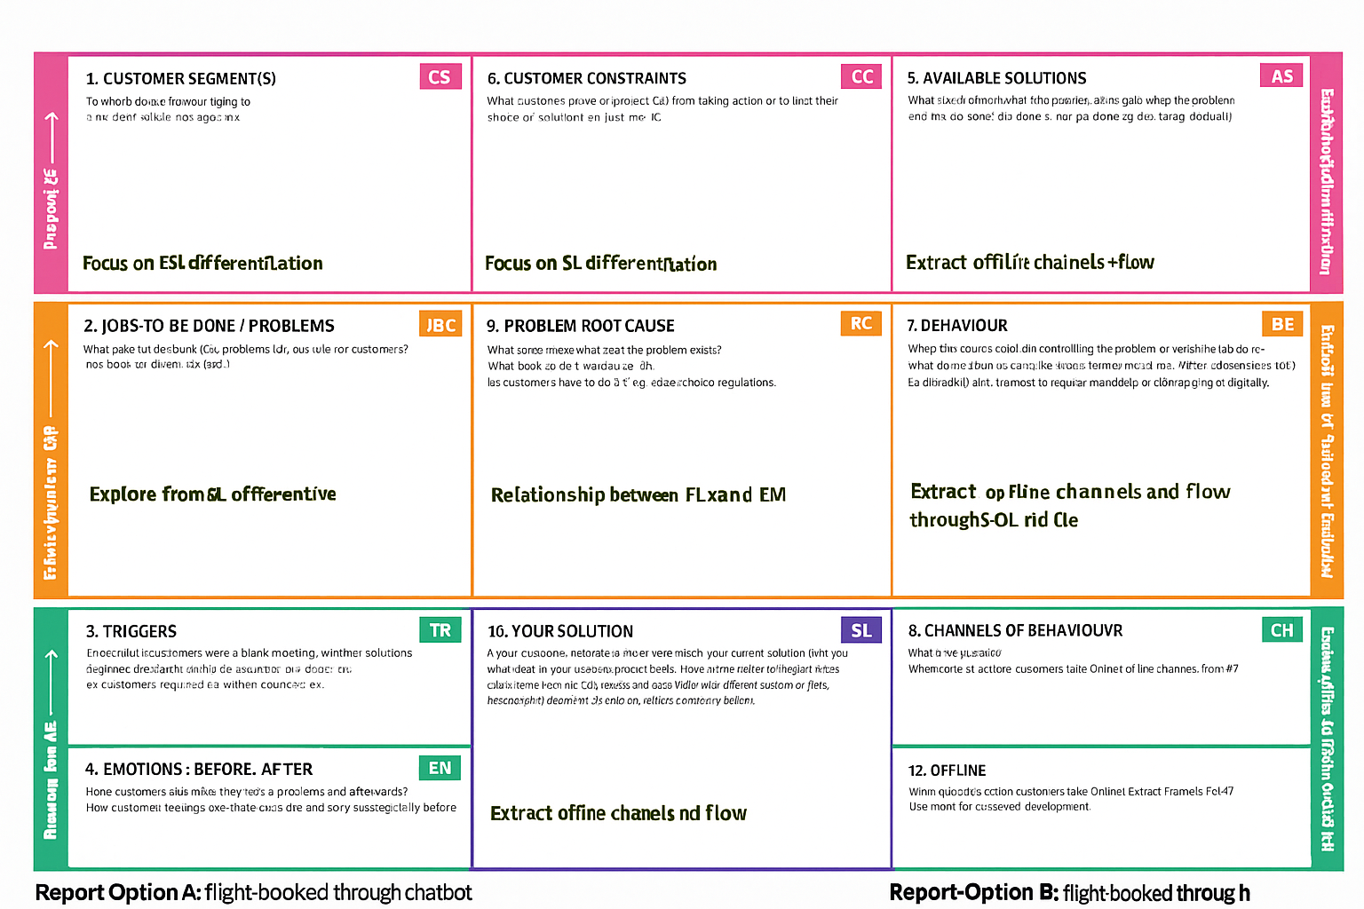

References:

[https://www.strategyzer.com/canvas/business-model-canvas](https://www.strategyzer.com/canvas/business-model-canvas%20)

<https://medium.com/@epicantus/problem-solution-fit-canvas-aa3dd59cb4fe>